**Financed emissions :** Financed emissions are the greenhouse gas (GHG) emissions associated with the investment and lending activities of financial institutions.

**The Partnership for Carbon Accounting Financials (PCAF)** is a financial industry-led initiative to help financial institutions assess and disclose the GHG emissions from their loans and investments through GHG accounting.

**GHG emissions with seven asset classes:**

* Listed equity and corporate bonds 上市股票和公司债券
* Business loans and unlisted equity 商业贷款和非上市股票
* Project finance 项目融资
* Commercial real estate 商业地产
* Mortgages 抵押贷款
* Motor vehicle loans  汽车贷款
* Sovereign debt 主权债务

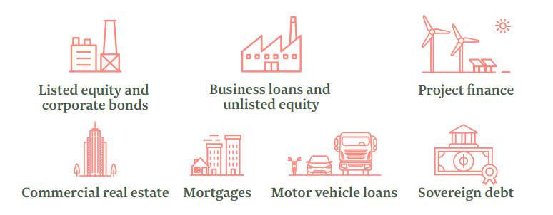

**Action:**

1. Measure and disclose
2. Set targets
3. Develop strategy
4. Take actions

**Financed emissions Scope:**

Scope 1: Direct emissions occur from sources owned or controlled by a company.

原产品

Scope 2: Indirect emissions stem from the purchased electricity consumed by a company.

电力购买

Scope 3: Indirect emissions occur in the value chain of the reporting company, including both upstream and downstream emissions.

上下游产业链

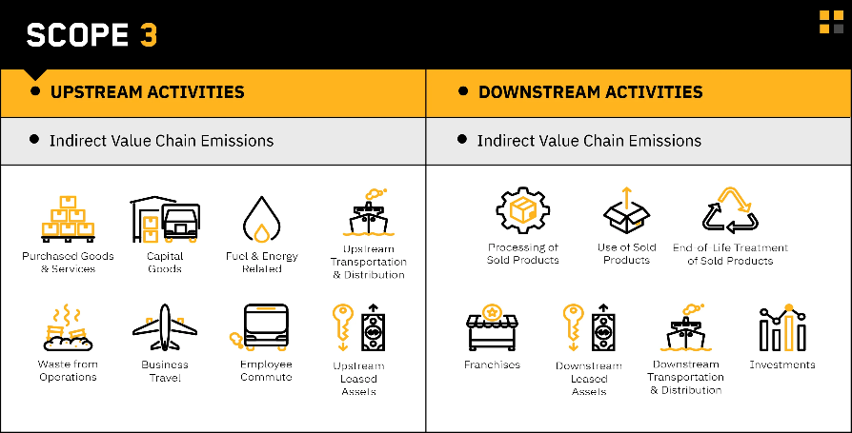

**Scope 1 and Scope 2** emissions are currently **mandatory** for some jurisdictions to report on. **Financed emissions fall into the Scope 3 category**